

BUILDING A TEAM FOR A
COMPREHENSIVE SCHOOL SAFETY PLAN
WORKBOOK

Increasing safety through a positive school climate involves many systems in the school and a dedicated effort from interested faculty, staff, and students. The heart of the process is a leadership team. Experienced principals would say that strong school teams are essential for planning and implementing change.
INTRODUCTION
Research supports the importance of establishing a permanent team to develop, guide and monitor tasked activities. Safety Leadership Team (SLT) is a standing committee/team which serves as the foundation for the school’s Comprehensive School Safety Plan.

Why is it important to establish a team?
- To hear different perspectives and areas of expertise can be heard.
- To generate buy-in and ownership in the prevention philosophy, activities, and programs.
- To increase the number of people in the organization who have a deep knowledge of prevention and have significant roles in achieving the team’s objectives and goals.
- To share workload and responsibilities.
Once the Safety Leadership Team members have been selected and the school leader has shared the mission for the team, team members need to take time to organize themselves to do the work. This workbook outlines 5 tasks for team members to discuss to create a well-functioning team:
Task 1 – Develop a Team Charter
Task 2 – Establish team norms
Task 3 – Identify team procedures
Task 4 – Select a decision-making process
Task 5 – Build a strong team
Templates for recording your discussions and organizing the team activities are available for each task. Discussion/reflection questions may help you explore issues more deeply. Go through these tasks at your organizational meeting or at a retreat. Once you have a complete Team Charter and have made policy and procedure decisions, check out the Action Planning modules in the Leader’s Guide online.

TASK 1: CREATING A SAFETY LEADERSHIP TEAM CHARTER
CREATING A SAFETY TEAM LEADERSHIP CHARTER
Once the team members have been selected, recruited, and mission has been outlined by the school leader, team members need to formalize their participation and the activities in a Team Charter.
Safety Leadership Team (SLT):
- Taking responsibility for planning, implementing, and monitoring school safety and climate efforts
- Communicating with other faculty, students, parents and the community about school safety and climate efforts

SLT CHARTER COMPONENTS

To be successful, SLT needs to develop a charter to guide its work. This charter is a commitment from participants do their share of the work. You may want to complete the Charter document after finishing Tasks 2, 3, and 4. Take a look at the Charter template at the end of the workbook.
But first, the SLT charter sets down in one place the basic facts about the team:
- the official name,
- team mission/purpose,
- members roles and contact information,
- dates and times for meetings
Here are some things that you may want to include after reviewing all the information in this workbook. The team mission/purpose sets out what you are working to accomplish. The decision process is important since it makes clear to members and the public how decisions will be made and who will make them. The location of the SLT within the organizational structure can be important in terms of the decision-making process. For instance, when we examined school policy initiatives, we saw how an SLT could be instrumental in reviewing existing school policies and looking to see what needs to be done regarding updating or revising existing policies or establishing new ones.
Click here to see a blank copy of a Team Charter for your use.
A template of the Team Charter is included on page 5.
DISCUSSION REFLECTION QUESTIONS

Here are some questions to consider:
- How can this Charter help this team get its work done?
- How can we expand the Charter as we find areas that are unclear?
- What do you need team members to do?

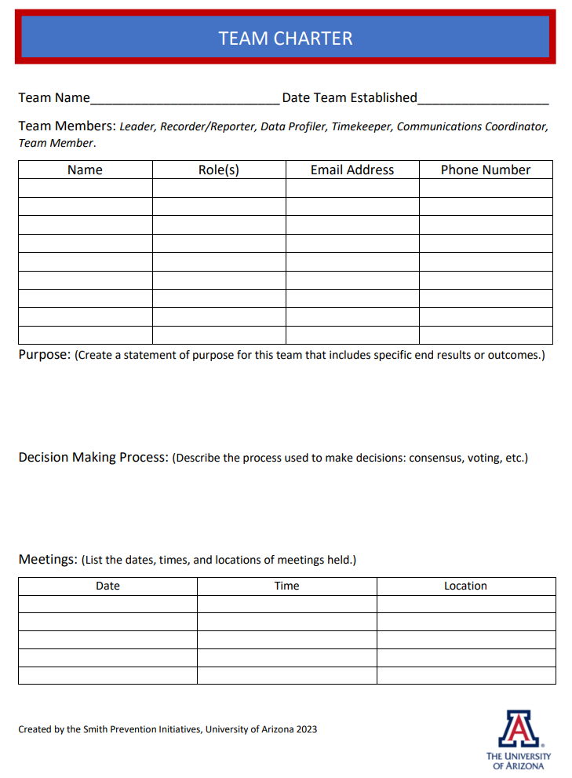

TASK 2: TEAM NORMS
This section provides guidance to team members on how to set up norms for the Safety Leadership Team (SLT).
TEAM NORMS:
Norms are the general pattern of behaviors that are expected of group members. They provide instructions for how the team will function. The reason for creating team norms is that one cannot assume everyone on the team has the same expectations.

By establishing team norms, questions about the expectations and possible conflict over clashing unspoken norms are reduced or eliminated. Team norms

- Help to hold the team and individual members accountable for their roles and for the outcomes.

- Lay out clearly the expectations for how team members will interact with one another within the team, with other staff members, and with the community.

- Help ensure that meetings are productive and efficiently run.

CREATING NORMS FOR SLT. STAY POSITIVE!
During one of the first meetings of the SLT, the members should identify the group norms. This process needs to involve all team members. The focus could be on how they want the group to operate so it can accomplish its goals. When creating the norms, the group should focus on the 5 -6 behaviors they would want to see happening. State these positively.

EXAMPLES OF TEAM NORMS
Other Ideas?
- Be prepared with reports, completed tasks.

- Participate in discussions.

- Listen to all ideas.

- Take responsibility for role expectations.

- Stay focused on the processes and outcomes.

You will notice that the norms are stated in the positive – letting team members know what they should do, not what they should not do.

When we explore the stages of team functioning, you will see how those norms may change after the team has had a chance to work together on some specific tasks.

Click here for Team Process and Norms form.
A template of the Team Process and Norms is included on page 8.
Once these norms are established, they should continue to be displayed publically so members can see them at each meeting. Some groups have put the norms permanently on the copy of the agenda, rather than posting them on a wall or door.

DISCUSSION REFLECTION QUESTION

Here is a question to consider:
- In other groups how have having norms helped with team functioning?
- What happens when a team strays from the norms?
- What’s missing from examples of team norms above?

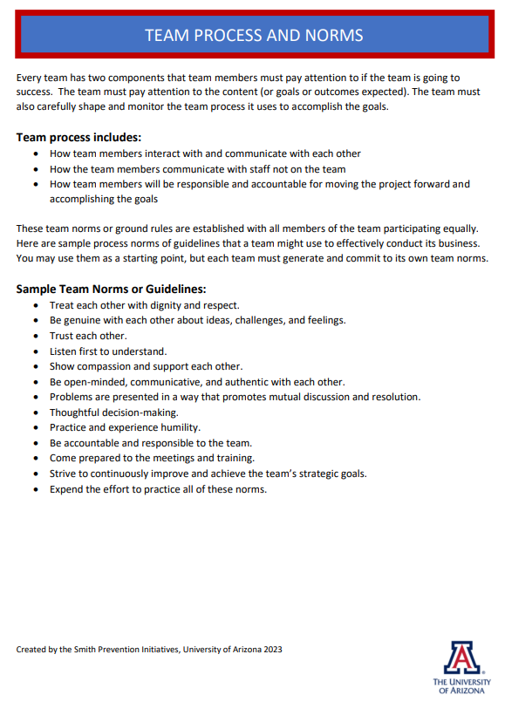

KEY ELEMENTS: Click here for Keys to an Effective Team Fact Sheet.
TASK 3: ESTABLISHING TEAM PROCEDURES
A fact sheet of the Keys to an Effective Team is included on pages 12 and 13.

Factors contributing to effective team functioning include expectations for participation, team members’ accountability, clear communication, and predictability. To gain more of an understanding of these key elements needed for effective team functioning, look at the definitions and descriptions of how these operate within a team.
- Participation – Team member involvement
- Accountability—Member responsibilities
- Predictability--Structures and processes that provide consistency and eliminate surprises.
- Communication--Sharing of messages and news from the team.

PARTICIPATION
Active participation is essential for any successful team functioning. At least 75% of the members should be present and engaged in all meetings. Norms are followed at each meeting.

All team members are encouraged to join in the conversation, share ideas, and offer constructive feedback. If someone is silent, it is a good idea for the leader to ask them to share their opinion after some discussion. All voices encouraged. It is also important that no one in the group dominates the discussion.

ACCOUNTABILITY

All team members need to come to meetings prepared and they need to complete all their responsibilities. Leadership is responsible for developing an agenda and having some record of the team decisions. Check out the meeting agenda template. How does it fit with your team’s style? Adjust as needed, but a specific format will help keep your team on task.

Click here to get a sample meeting agenda.
A sample copy of the meeting agenda is included on page 14.

Evaluation is another part of accountability. There needs to be a regular assessment of the team process, the team member roles, and outcomes. The team can be accountable to the organization by reviewing data, monitoring all their activities, and documenting progress towards meeting goals.

PREDICTABLITITY

Initially, meetings need to happen at least every 2 weeks to establish the team, mission, charter, and data collection. As the team moves into the implementation of your safety /climate activity, process or program, frequently. Once you have worked all the kinks out of the process, meetings should be scheduled at least monthly. In fact, it is a good idea to have a meeting calendar that covers a semester, or even a whole year, so people can schedule meeting times on their calendar and avoid time/meeting conflicts. There is a place on the Team Charter to note meeting dates.

Meetings should be held even in the leader or facilitator’s absence, and therefore it is important to have an organization form that identifies a backup person for each role. The meetings should start and end on time, and again, the next meeting should be scheduled before the end of the current meeting. In terms of roles, responsibilities, and expectations, each should be defined as previously discussed.

There also needs to be an agenda, which is distributed in advance and used to guide the meeting. It is important that meeting minutes/notes are taken and shared.

A process needs to be in place for team members to add or correct the minutes. The team needs to decide who besides team members will receive the meeting minutes. Those to be considered are administrators, faculty, staff, or other stakeholders. The team could decide not to share minutes and identify other means for sharing the activities of the team, such as reporting at a faculty meeting or providing a summary in a newsletter.

There also needs to be a status check on objectives and activities. There is a tendency sometimes to focus on one objective or one activity and not look at the whole range of safety activities being implemented on-site.

INTERNAL AND EXTERNAL COMMUNICATION
The fourth key element for effective team functioning is communication. Communication in high-performing teams encompasses a broad range of formal and informal ways for people to exchange ideas and information. The underlying theme is that all communication is open and honest. It speaks about how the team members communicate with each other, with the leadership, and with the rest of the school staff and other stakeholders.
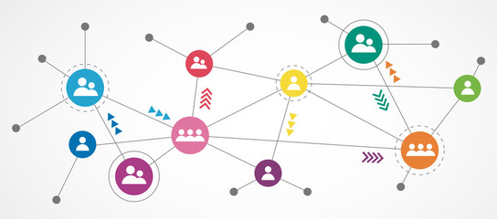

Communication on a regular basis maintains support for activities, offers the opportunity for feedback and helps identify potential problems. To maintain support for the Comprehensive School Safety Plan, it is critical that all staff have regular information about the safety plan activities.

The team needs to establish regular channels of communication about safety goals, activities, and progress in meeting goals with all stakeholders to keep the school community informed of the safety activities and to gain support for them. Some teams have used short presentations at all staff meetings, newsletters, bulletin boards, blogs, websites, and newspaper articles.

Click here for SLT Membership Checklist.
A template of the SLT Membership Checklist is included on page 15.

DISCUSSION/REFLECTION QUESTIONS
Here are some questions to consider:
- Are there other points about participation on a team that someone would like to add?
- Are there other points about accountability that someone would like to add?
- Are there other points about predictability that someone would like to add?
- Are there other points about communication that someone would like to add?

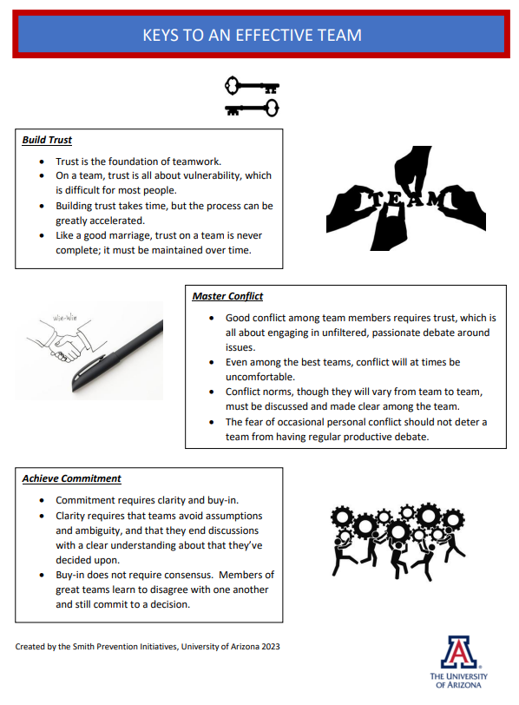

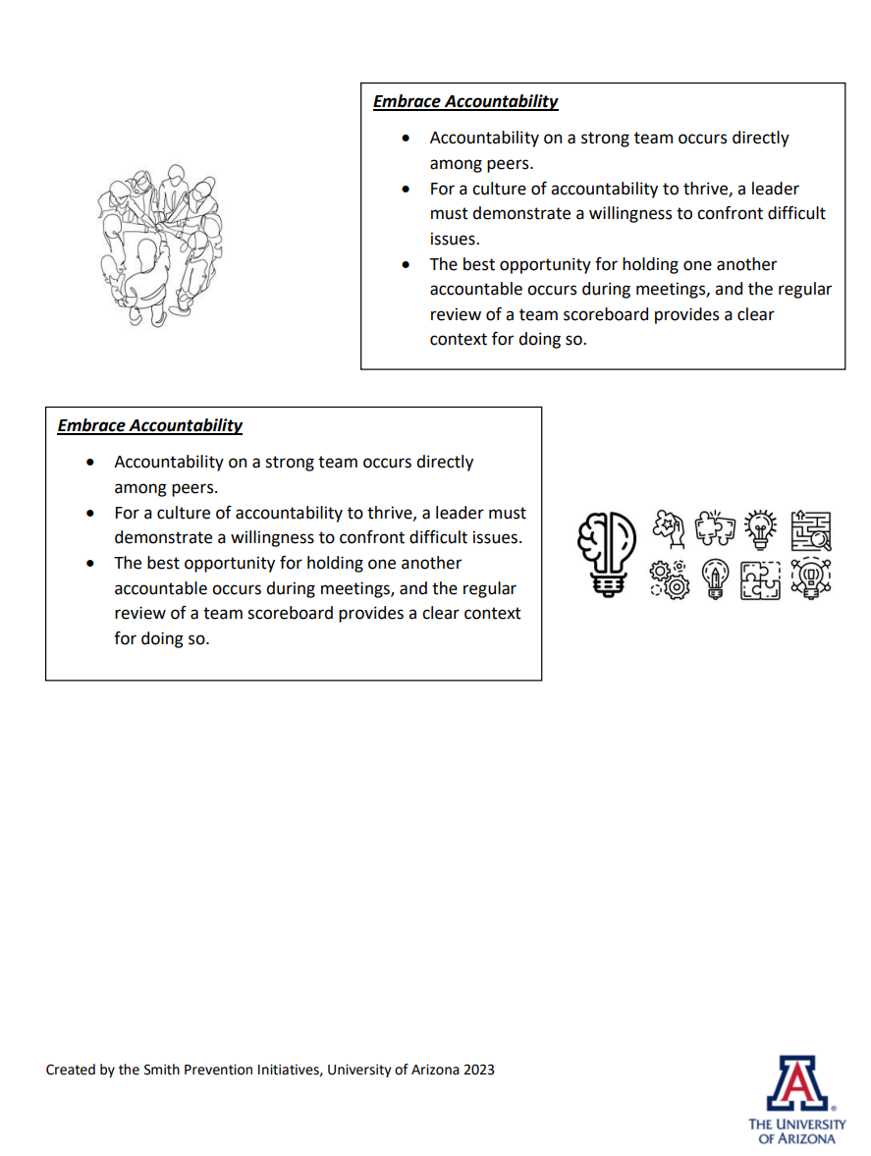

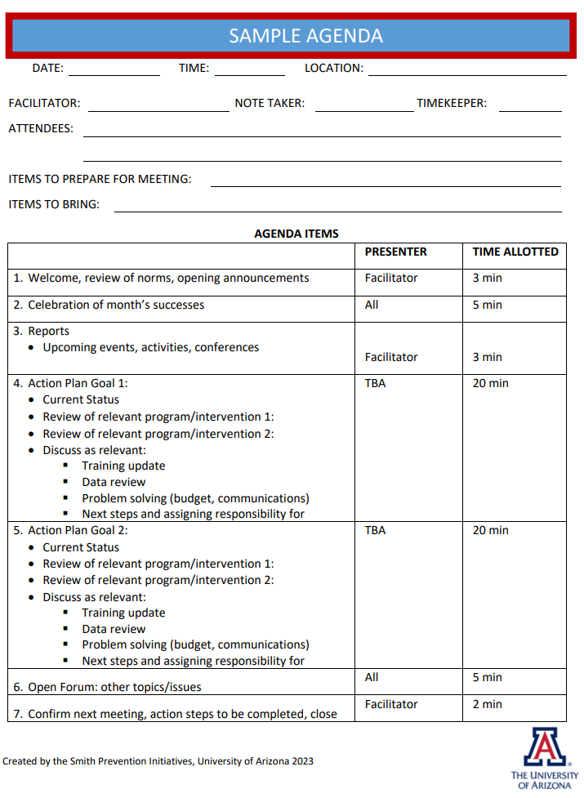

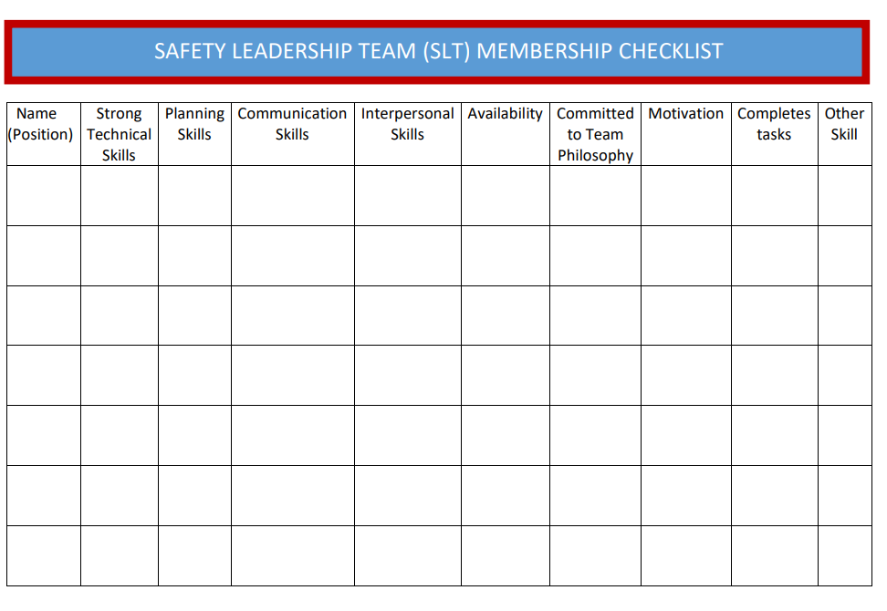

TASK 4: DECISION-MAKING PROCESS
DECISION-MAKING PROCESS IN PARTICIPATION
Understanding the various types of decision-making processes is important in team formation and should be addressed early in the team process. The decision-making process is critical to team success.

There are several ways that decisions can be reached:
- The democratic process, in which the majority wins.
- Consensus, in which decisions are accepted when there is full (total) agreement by everyone in the meeting.
- Compromise, which is negotiated until everyone accepts the decision. In a compromise, most participants do not get 100% of what they want but are willing to live with the result of the decision.
- Authority, the team will generate ideas and discuss but the final decision would be made by the principal or other authority within the school. In this case, the team acts in an advisory capacity.

Once you have made the decision-making choice, your charter is complete. Everyone should sign it with their contact information.

DISCUSSION/REFLECTION QUESTIONS
Here are some questions to consider:
- What are the pros and cons of each type of decision making?
- What style of decision making are you MOST comfortable with?
- What style of decision making are you LEAST comfortable with?
- What times might there be when you will use another form that is not listed on your Charter?

TASK 5: TEAM BUILDING
Team building is a conscious process that helps a group accomplish increasingly complex goals through building capacity. Team building activities should focus on cooperative activities. Getting a group of people together does not automatically mean you have a team. Think of the members of the SLT as pieces of a puzzle.



You have already taken the first steps toward team functioning in your team charter. Figuring out how the different pieces fit together for the best results takes some time and attention to the process of becoming a team. Acknowledge positive contributions and celebrate team successes. We will now talk about some strategies and approaches leaders can take to help the SLT function at its best.

KEEPING AND RENEWING TEAMS
Once a team is formed, we move into a new phase – maintaining the team. The accomplishment of this phase must be a conscious process. Some components include:

- Meeting regularly and consistently.
- Reflecting and evaluating regularly (monthly, quarterly, etc.).
- Celebrating team members and team accomplishments.
- Being productive.
- Integrating activities to energize team members.
- Identifying training and retraining needs.

STAGES OF TEAM DEVELOPMENT
No matter how perfectly everyone on a team gets along, or how skilled they are at group processes and team skills, every team will go through steps as it develops into maturity.
Understanding these phases and helping teams move through them is essential to making teams fully functional. It is important that a team does not avoid the more difficult stages of development. The model documents the five stages of team development and highlights the role leaders and team members can plan in helping the team move through those stages to be more productive.

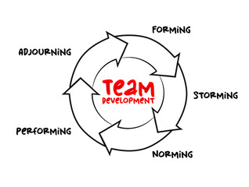
FORMING OR NOMINAL COMMUNITY
The initial phase of any group involves forming, and that is setting up the objectives, goals, and structures for the team. The focus in this phase should be understanding the team’s goals, and individual team member roles.

For team members, there is often a feeling of uncertainty about the team, its goals, and the role they play on the team. There may be initial discomfort and worry about acceptance by other team members. The leader is crucial in clarifying the role of the team and team members in this phase.

STORMING OR CHAOS
The next phase is storming, and here the focus is on team organization and strengthening of team goals and roles. This usually occurs after the team gets moving with some activity. Some of the characteristics include conflict among team members or between team members and the leaders. Some of the conflicts might arise from uneven or lack of participation or competition.

Other characteristics may be placing different levels of priority on group activities and moving toward group norms. In this phase, the leader needs to be supportive, listen actively, manage conflict, and look to drive for consensus. Sometimes this means a leader needs to meet individually with team members or can deal with the issue/s in the whole group. The leader must be comfortable with conflict. This phase is necessary for people to pass through to be a more effective team.

NORMING OR EMPTYING
The third phase norming is when the team becomes more effective. The norms are established for behavior and goals, and the team structure is in place. The team characteristics of this phase include trust and respect that are established among team members.

The idea is “I may not agree with everything you say or stand for, but I respect you and we are able to work together for a goal we agree upon.” There is more support for the team leader, and the team becomes more cohesive. The role of the leader in the norming phase is to recognize group and individual efforts, to provide learning opportunities and feedback, and to share the leadership responsibilities.

PERFORMING OR FULLY FUNCTIONING COMMUNITY
The next phase of group and team development is the performing stage in which the teams are most effective in accomplishing their goals. There is direct two-way communication among team members, increased collaboration and cooperation, and shared responsibility. Team members are adaptable, and the team has frequent self-evaluations and celebrations of success. In the performing stage, the role of the leader is to focus on the purpose of the team, build relationships, coach members, remove the barriers, and empower team members to meet team goals.

ADJOURNING OR TRANSFORMING
Teams who have a short-lived purpose will need to adjourn when it is completed or transform into doing another task. For example, a team that has completed its task of reviewing a policy and making decisions about a new policy may either adjourn or transform into doing another task.

The planning the team and the team leader do initially in setting the team’s scope and goals are critical in knowing when it is time for the team to either adjourn or transform. Characteristics may include that there is recognition of the team and individual efforts, there may be sadness if the team ends, and uncertainty if the team reforms for new goals.

A period of significant change that may happen in some groups. Types of changes that may occur include losing or adding members, redefining a team’s primary mission, or a total break-up of the team. Any of these changes have a major impact on the team and will force members to address their fundamental expectations, goals, norms, and ground rules. In many cases, teams will regress to one of the previous stages and then work their way back to achievement.



- Celebrating team members and team accomplishments.
- Being productive.
- Integrating activities to energize team members.
- Identifying training and retraining needs.

ADDRESSING TURNOVER
Turnover happens on every team. It is essential to address turnover before a key team member leaves and there is no plan to replace that person. A challenge for a team’s leadership will be how to smoothly transition new members onto the team. It is best to have a plan in place.
- Identify the skills and knowledge of and the roles filled by the person leaving.
- Determine if the skills, knowledge, and roles need to be replaced.
- Identify potential team members who can fill the vacancy (See Characteristics of Successful Team Members above).
- Orient new team members to expectations and processes of team functioning.

DISCUSSION REFLECTION QUESTIONS
Here are some questions to consider:
- What other ideas do you have about “Forming”?
- What other ideas do you have about “Storming”?
- What other ideas do you have about “Norming”?
- What other ideas do you have about “Performing”?
- What other ideas do you have about “Adjourning or Transforming”?

WHAT’S NEXT…REVIEW THE ACTION PLANNING TAB.

Conzemius, Anne, (2014). The handbook for SMART school teams : revitalizing best practices for collaboration. Bloomington, IN :Solution Tree Press,
Conzemius, Anne, (2014). The handbook for SMART school teams : revitalizing best practices for collaboration. Bloomington, IN :Solution Tree Press.
Conzemius, Anne, (2014). The handbook for SMART school teams : revitalizing best practices for collaboration. Bloomington, IN :Solution Tree Press.

